

5/15/2023



Heart Failure Risk

Assessment Model

# TEAM MOLVIS

**Heart Failure Risk Assessment Model**

**Team Molvis**

|  |  |  |  |
| --- | --- | --- | --- |
| 1 | 21F-9079 | Saad Habib | BSCS-6D |
| 2 | 21F-9127 | Abdul Basit | BSCS-6D |
| 3 | 21F-9141 | Syed Burhan | BSCS-6D |

## Problem Statement

Heart failure is a significant health issue with high mortality rates and early identification of patients at risk of adverse outcomes is crucial for timely interventions and improved patient care. This project aims to analyze a dataset comprising patient information, including age, CPK levels, Ejection fraction, and death events, in order to address the problem of predicting mortality risk in heart failure patients.

1. **Objective**

By exploring the relationships and patterns within the data, the objective is to develop a robust predictive model that can accurately identify patients who are more likely to experience fatal outcomes. The outcomes of this project will provide healthcare practitioners with valuable insights and tools to proactively identify high-risk patients, tailor treatment strategies, and allocate resources efficiently to ultimately reduce mortality rates associated with heart failure.

1. **Data Description**

The data for this project is obtained from a document “Heart Failure Clinical Records Analysis” by Lorenzo De Nisi. The document is available on the website KAGGLE <https://www.kaggle.com/code/lorenzodenisi/heart-failure-clinical-records-analisys>

The dataset includes information on 1800 patients, including their age, creatinine phosphokinase (CPK), ejection fraction, death events.

**Age:** The dataset includes individuals ranging from 40 to 95 years old. This information suggests that age is a significant factor to consider when assessing the risk of death.

**Creatinine Phosphokinase (CPK**): The dataset includes varying levels of CPK, which is an enzyme found primarily in the heart, brain, and skeletal muscle. Elevated CPK levels may indicate heart muscle damage or other health conditions.

**Ejection Fraction:** The ejection fraction measures the percentage of blood pumped out of the heart with each heartbeat. A lower ejection fraction indicates reduced heart function, which can be indicative of heart failure.

**Death Event:** This variable indicates whether the patient survived or experienced a death event during the follow-up period. A value of 1 represents a death event, while a value of 0 indicates that the patient survived.

1. **Results**
   1. Mean, Median, Variance and Standard Deviation of AGE:

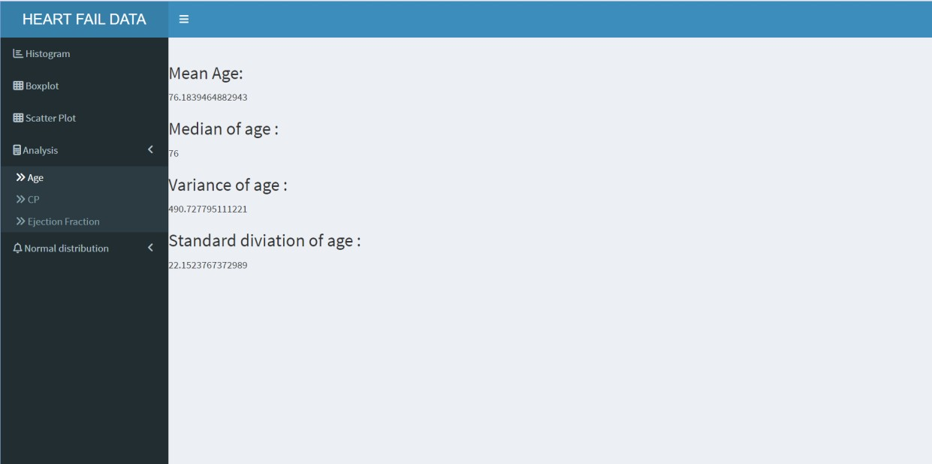

*Figure 1.1 AGE*

* 1. Mean, Median, Variance and Standard Deviation of CPK:

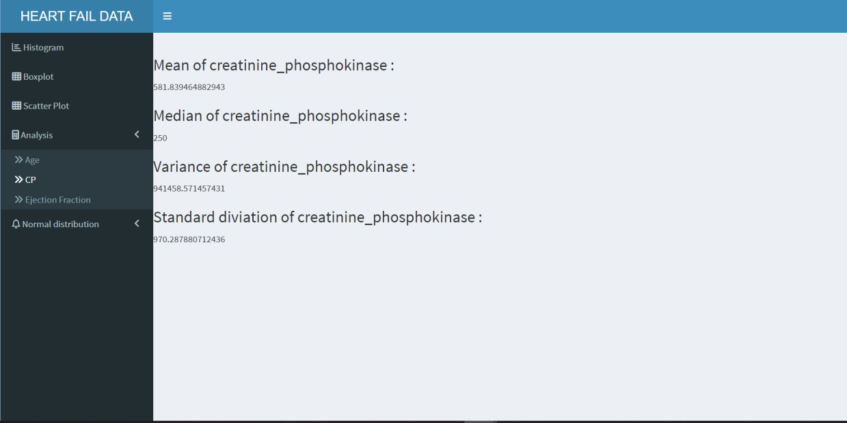

*Figure 1.2 CPK*

### Mean, Median, Variance and Standard Deviation of Ejection Fraction:

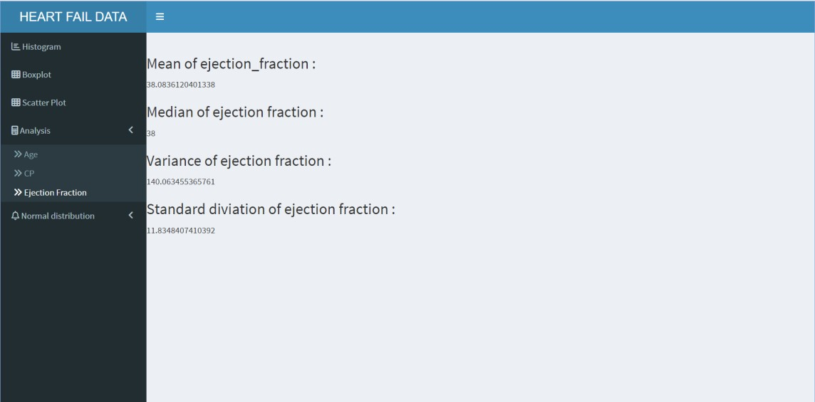

*Figure 1.3 EF*

### Histograms of age, Ejection Fraction and Creatinine Phosphokinase:

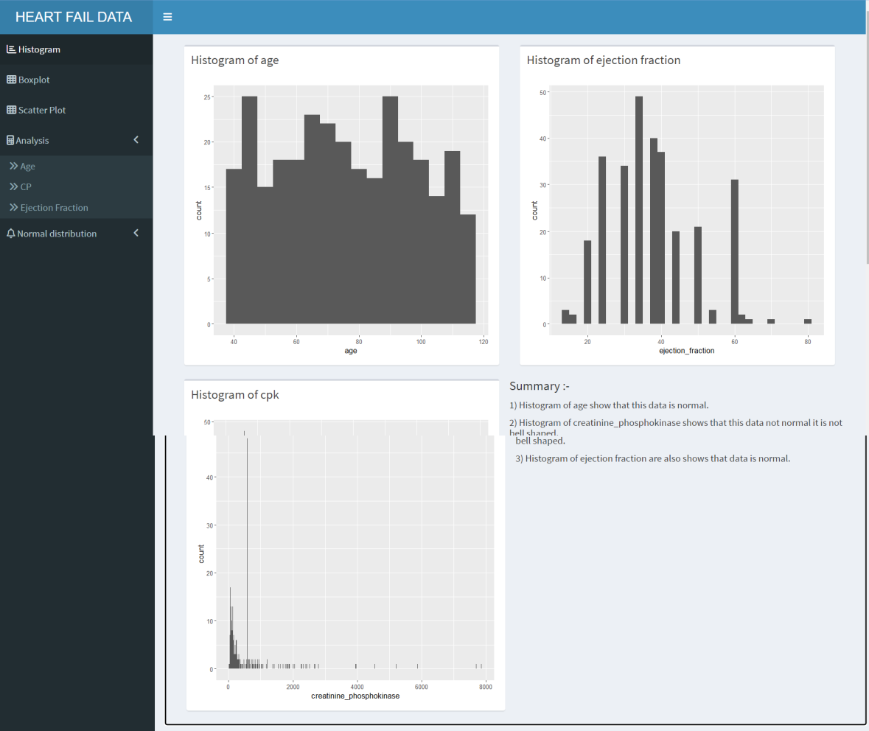

*Figure 2 Histogram*

### Box-Plot of Age, Ejection Fraction and Creatinine Phosphokinase:

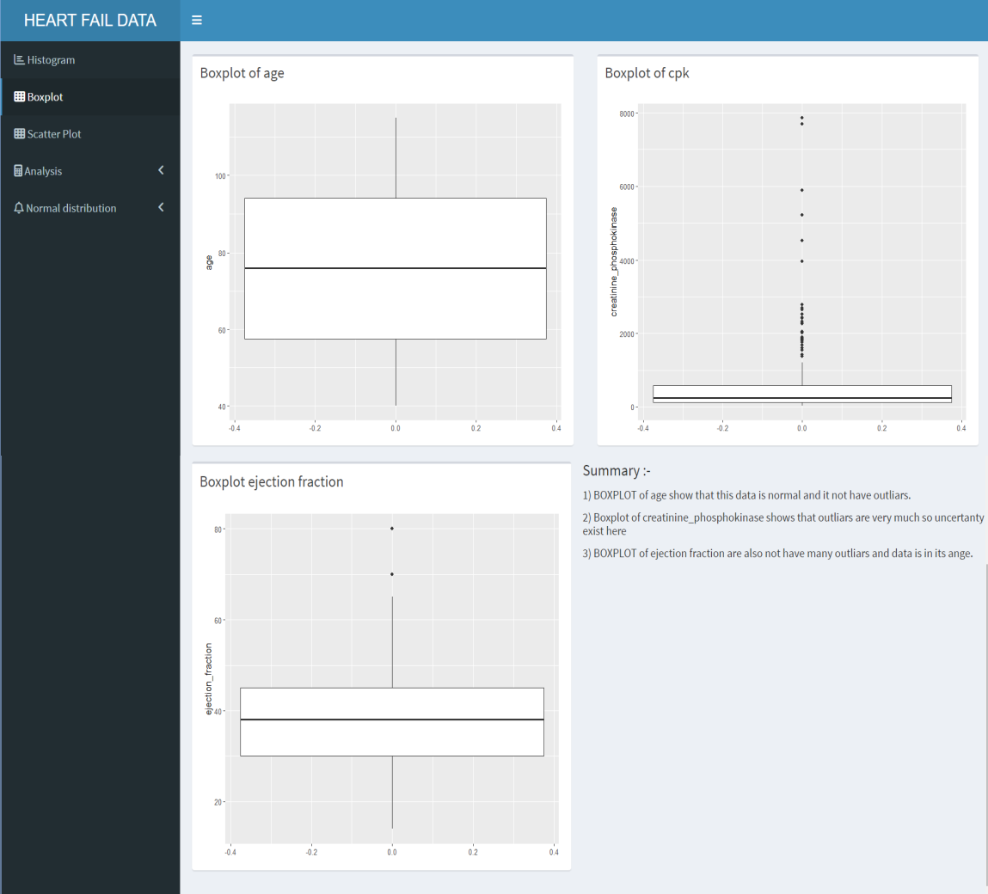

*Figure 3 Box-Plot Age, CPK, EF*

### Scatter-Plot of Ejection Fraction and Creatinine Phosphokinase:

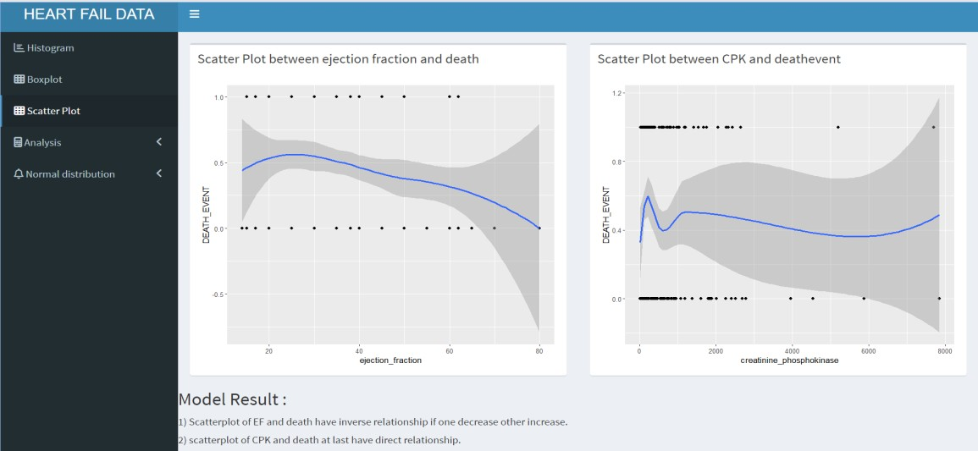

*Figure 4 Scatter-Plot EF and CPK*

### Normal Distribution of Ejection Fraction and Creatinine Phosphokinase:

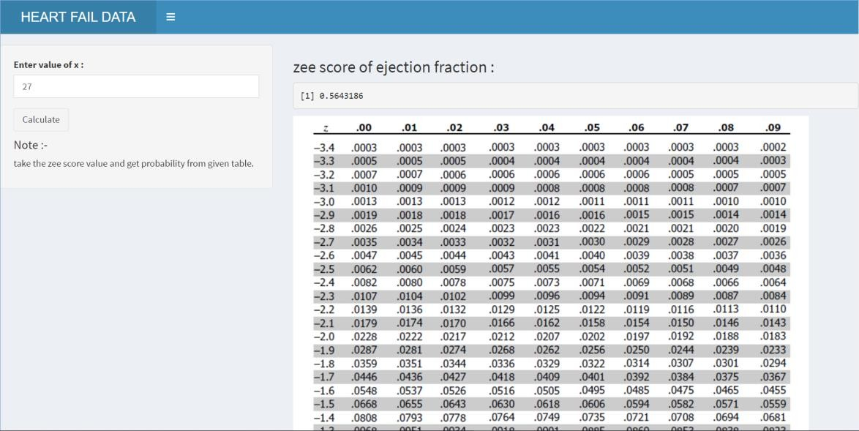

*Figure 5.1 Z-Score of EF*

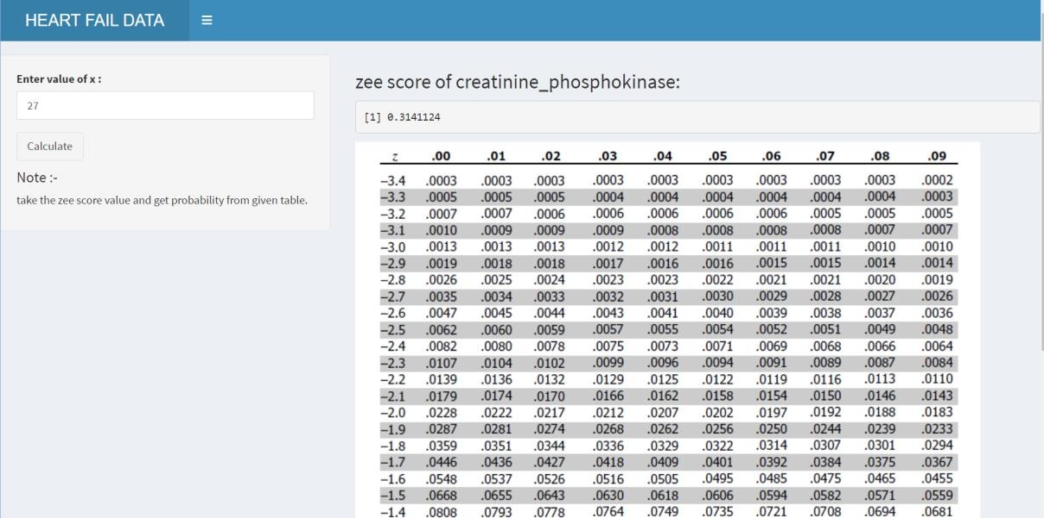

*Figure 5.2 Z-Score of CPK*

## R codes

library(shiny) library(shinydashboard) library(ggplot2) library(DT)

getwd();

# Load data from CSV file

mydata <- read.csv("clinical.csv", header = TRUE) class(mydata)

# Define UI

ui <- dashboardPage(

dashboardHeader(title = "HEART FAIL DATA ANALYSIS"), dashboardSidebar(

sidebarMenu(

menuItem("Histogram", tabName = "histogram", icon = icon("bar-chart")), menuItem("Boxplot", tabName = "boxplot", icon = icon("th")), menuItem("Scatter Plot", tabName = "scatterplot",icon = icon("th")), menuItem("Analysis", tabName = "analysis", icon = icon("calculator"),

menuSubItem("Age", tabName = "age_analysis"), menuSubItem("CP", tabName = "cp_analysis"), menuSubItem("Ejection Fraction", tabName = "ef_analysis")),

menuItem("Normal distribution",tabname="normal",icon=icon("bell"), menuSubItem("CPK",tabName = "cpk_normal"), menuSubItem("Ejection fraction",tabName = "ej_normal")

)

)

),

dashboardBody( tabItems(

tabItem(tabName = "histogram", fluidPage(

box(title = "Histogram of age", plotOutput("hist_plot1", height = "400px")),

box(title = "Histogram of ejection fraction", plotOutput("hist_plot2", height = "400px")), box(title = "Histogram of cpk", plotOutput("hist_plot3", height = "400px")), h4("Summary :- "),

h5("1) Histogram of age show that this data is normal."),

h5("2) Histogram of creatinine_phosphokinase shows that this data not normal it is not bell shaped."), h5("3) Histogram of ejection fraction are also shows that data is normal.")

)

),

tabItem(tabName = "boxplot", fluidRow(

box(title = "Boxplot of age", plotOutput("box_plot1", height = "400px")), box(title = "Boxplot of cpk", plotOutput("box_plot2", height = "400px")),

box(title = "Boxplot ejection fraction", plotOutput("box_plot3", height = "400px")), h4("Summary :- "),

h5("1) BOXPLOT of age show that this data is normal and it not have outliars."),

h5("2) Boxplot of creatinine_phosphokinase shows that outliars are very much so uncertanty exist here"), h5("3) BOXPLOT of ejection fraction are also not have many outliars and data is in its ange.")

)

),

tabItem(tabName = "scatterplot", fluidRow(

box(title = "Scatter Plot between ejection fraction and death", plotOutput("scatter_plot1", height = "400px")), box(title = "Scatter Plot between CPK and deathevent", plotOutput("scatter_plot2", height = "400px")), h3("Model Result :"),

h5("1) Scatterplot of EF and death have inverse relationship if one decrease other increase."), h5("2) scatterplot of CPK and death at last have direct relationship.")

)

),

tabItem(tabName = "age_analysis", fluidRow( uiOutput("output_ui"), uiOutput("output_ui1"), uiOutput("output_ui2"),

uiOutput("output_ui3")

)

),

tabItem(tabName = "cp_analysis", fluidRow( uiOutput("output_ui4"), uiOutput("output_ui5"), uiOutput("output_ui6"), uiOutput("output_ui7")

)

),

tabItem(tabName = "ef_analysis", fluidRow( uiOutput("output_ui8"), uiOutput("output_ui9"), uiOutput("output_ui10"), uiOutput("output_ui11")

)

),

tabItem(tabName = "ej_normal", fluidRow(

sidebarLayout( sidebarPanel(

numericInput("x", "Enter value of x :", value = 0), actionButton("submit", "Calculate"),

h4("Note :-"),

h5("take the zee score value and get probability from given table.")

),

mainPanel(

h3("zee score of ejection fraction :"), verbatimTextOutput("result"),

tags$img(src = "saad.png", height = "759px", width = "759px")

)

)

)

),tabItem(tabName = "cpk_normal", fluidRow(

sidebarLayout( sidebarPanel(

numericInput("y", "Enter value of x :", value = 0), actionButton("submit", "Calculate"),

h4("Note :-"),

h5("take the zee score value and get probability from given table.")

),

mainPanel(

h3("zee score of creatinine_phosphokinase:"), verbatimTextOutput("result1"),

tags$img(src = "saad.png", height = "759px", width = "759px")

)

)

)

)

)

)

)

# Define server

server <- function(input, output) { output$output_text23 <- renderText({ h2("This is the output text.")

})

output$result <- renderPrint({ normal_ejection(input$x)

})

output$result1 <- renderPrint({ normal_cretanin(input$y)

})

normal_ejection <- function(v) {

n <- length(mydata$ejection_fraction) for (i in 1:n) {

if (i == v) {

return(pnorm(mydata$ejection_fraction[i], mean(mydata$ejection_fraction), sd(mydata$ejection_fraction)))

}

}

return(NA) # return NA if value not found

}

normal_cretanin <- function(v) {

n <- length(mydata$creatinine_phosphokinase) for (i in 1:n) {

if (i == v) {

return(pnorm(mydata$creatinine_phosphokinase[i], mean(mydata$creatinine_phosphokinase), sd(mydata$creatinine_phosphokinase)))

}

}

return(NA) # return NA if value not found

}

output$output_ui <- renderUI({ mean_age <- age_mean() tags$div(

h3("Mean Age:"), tags$p(mean_age)

)

})

output$output_ui1 <- renderUI({ median_age <- age_median() tags$div(

h3("Median of age :"), tags$p(median_age)

)

})

output$output_ui2 <- renderUI({ var_age <- age_var()

tags$div(

h3("Variance of age :"), tags$p(var_age)

)

})

output$output_ui3 <- renderUI({ sd_age <- age_sd()

tags$div(

h3("Standard diviation of age :"), tags$p(sd_age)

)

})

output$output_ui4 <- renderUI({ mean_cpk <- cpk_mean() tags$div(

h3("Mean of creatinine_phosphokinase :"), tags$p(mean_cpk)

)

})

output$output_ui5 <- renderUI({ median_cpk <- cpk_median() tags$div(

h3("Median of creatinine_phosphokinase :"), tags$p(median_cpk)

)

})

output$output_ui6 <- renderUI({ var_cpk <- cpk_var()

tags$div(

h3("Variance of creatinine_phosphokinase :"), tags$p(var_cpk)

)

})

output$output_ui7 <- renderUI({ sd_cpk <- cpk_sd()

tags$div(

h3("Standard diviation of creatinine_phosphokinase :"), tags$p(sd_cpk)

)

})

output$output_ui8 <- renderUI({ mean_ejection <- ejection_mean() tags$div(

h3("Mean of ejection_fraction :"), tags$p(mean_ejection)

)

})

output$output_ui9 <- renderUI({ median_ejection <- ejection_median() tags$div(

h3("Median of ejection fraction :"), tags$p(median_ejection)

)

})

output$output_ui10 <- renderUI({ var_ejection <- ejection_var() tags$div(

h3("Variance of ejection fraction :"), tags$p(var_ejection)

)

})

output$output_ui11 <- renderUI({ sd_ejection <- ejection_sd() tags$div(

h3("Standard diviation of ejection fraction :"), tags$p(sd_ejection)

)

})

# Render histogram subplots output$hist_plot1 <- renderPlot({

ggplot(mydata, aes(x = age)) + geom_histogram(binwidth = 5)

})

output$hist_plot2 <- renderPlot({

ggplot(mydata, aes(x = ejection_fraction)) + geom_histogram(binwidth = 2)

})

output$hist_plot3 <- renderPlot({

ggplot(mydata, aes(x =creatinine_phosphokinase)) + geom_histogram(binwidth = 10)

})

# Render boxplot subplots output$box_plot1 <- renderPlot({

ggplot(mydata, aes( y = age)) + geom_boxplot()

})

output$box_plot2 <- renderPlot({

ggplot(mydata, aes( y =creatinine_phosphokinase )) + geom_boxplot()

})

output$box_plot3 <- renderPlot({

ggplot(mydata, aes( y =ejection_fraction)) + geom_boxplot()

})

# Render scatter plot subplots output$scatter_plot1 <- renderPlot({

ggplot(mydata, aes(x =ejection_fraction,y=DEATH_EVENT)) + geom_point()+geom_smooth()

})

output$scatter_plot2 <- renderPlot({

ggplot(mydata, aes(x = creatinine_phosphokinase, y =DEATH_EVENT )) + geom_point()+geom_smooth()

})

age_mean<-function(){ x<-mean(mydata$age) return (x)

}

age_median<-function(){ return(median(mydata$age));

}

age_var<-function(){ return(var(mydata$age))

}

age_sd<-function(){ return (sd(mydata$age))

}

cpk_mean<-function(){

x<-mean(mydata$creatinine_phosphokinase) return (x)

}

cpk_median<-function(){ return(median(mydata$creatinine_phosphokinase));

}

cpk_var<-function(){ return(var(mydata$creatinine_phosphokinase))

}

cpk_sd<-function(){

return (sd(mydata$creatinine_phosphokinase))

}

ejection_mean<-function(){

x<-mean(mydata$ejection_fraction) return (x)

}

ejection_median<-function(){ return(median(mydata$ejection_fraction));

}

ejection_var<-function(){ return(var(mydata$ejection_fraction))

}

ejection_sd<-function(){

return (sd(mydata$ejection_fraction))

}

# Render mean and median tables output$mean_analysis <- renderText({

mean_data <- data.frame(Age = mean(mydata$age), CP = mean(mydata$cp), Ejection_Fraction = mean(mydata$ejection_fraction))

colnames(mean_data) <- c("Mean age", "Mean CP", "Mean Ejection Fraction") mean_data

})

output$median_analysis <- renderTable({

median_data <- data.frame(Age = median(mydata$age), CP = median(mydata$cp), Ejection_Fraction = median(mydata$ejection_fraction))

colnames(median_data) <- c("Median Age", "Median CP", "Median Ejection Fraction") median_data

})

# Render variance and standard deviation tables output$variance_analysis <- renderTable({

var_data <- data.frame(Age = var(mydata$age), CP = variance_cp(mydata$cp), Ejection_Fraction = variance_ef(mydata$ejection_fraction))

colnames(var_data) <- c("Variance Age", "Variance CP", "Variance Ejection Fraction") var_data

})

output$standarddeviation_analysis <- renderTable({

sd_data <- data.frame(Age = standarddeviation(mydata$age), CP = standarddeviation_cp(mydata$cp), Ejection_Fraction = standarddeviation_ef(mydata$ejection_fraction))

colnames(sd_data) <- c("Standard Deviation Age", "Standard Deviation CP", "Standard Deviation Ejection Fraction") sd_data

})

# render normal distribution output$normaldistribution_analysis <- renderTable({

sd_data <- data.frame(CP = normaldistribution_cp(mydata$cp), Ejection_Fraction = normaldistribution_ef(mydata$ejection_fraction))

colnames(sd_data) <- c("Normal Distribution CP", "Normal Distribution Ejection Fraction") sd_data

})

}

shinyApp(ui, server)

## Conclusion

The conclusion of this project is that in scatter plot of CPK and DEATH_EVENT in last of plotting the curve is increase it have direct relationship between CPK and DEATH_EVENT while the relationship between EJECTION_FRACTION and DEATH_EVENT it have negative linear relationship so the relationship between EJECTION_FRACTION and DEATH_EVENT is inverse if one increase other decrease and it also find probability using normal distribution so, It will provide healthcare practitioners with valuable insights and tools to proactively identify high-risk patients, tailor treatment strategies, and allocate resources efficiently to ultimately reduce mortality rates associated with heart failure.